Lesson 4 Visual Line Following Integration with micro:bit

Preparation
Connect WonderCam to micro:bit Expansion Board Port 4.
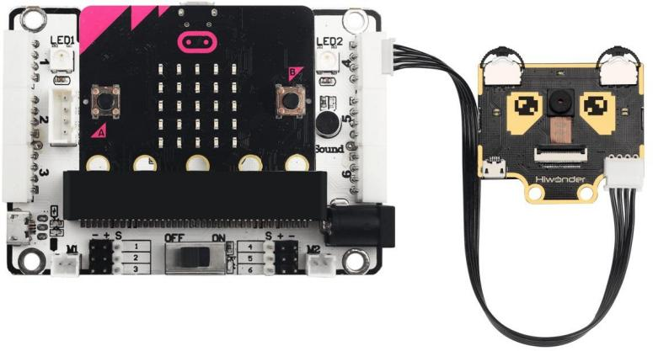

Learning Objective
- To know the connectivity of WonderCam on micro:bit Expansion Board.
- To understand the program logic.

Programming Plan
In this lesson, we will integrate the Vision module Visual Line Following function with the output from micro:bit Expansion Board. The program will first initialize the Vision module following by detecting the line and present it on the micro:bit Dot Matric Display.

Programming

Adding Extension

Go to https://makecode.microbit.org/ and create New Project. In the MakeCode Toolbox, select Advanced, click on Extensions to add the following two extension packs:

https://github.com/hiwonder/wondercam
https://github.com/Hiwonder/Startbit

Command Blocks

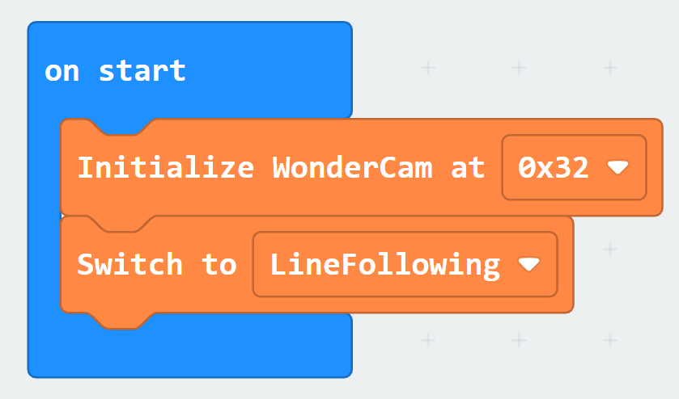
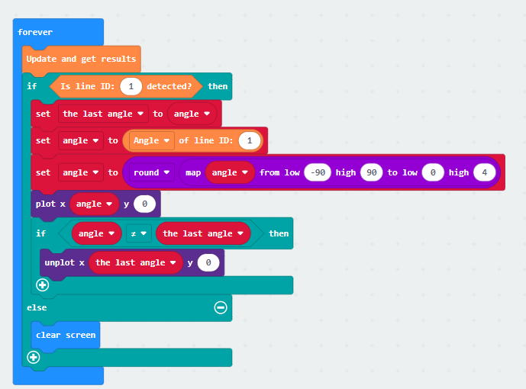

4.1 Pairing devices and program download
- Connect micro:bit to computer.
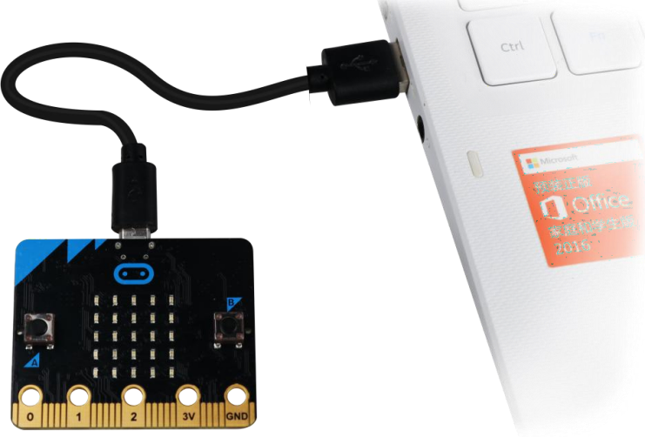

- Click on “…” located beside“Download” and select “Pair device”.
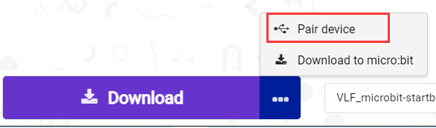

- Click on on “Pair device” on the Pop-up screen.
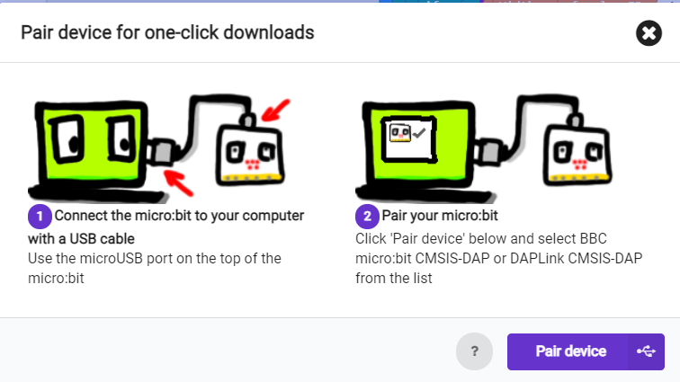

- Click “Connect” as shown in image below.

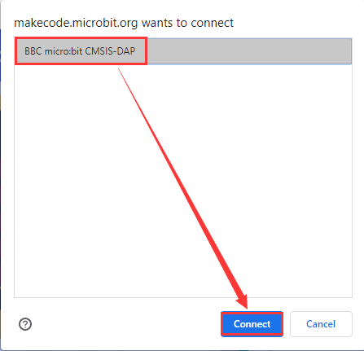
- Once connection is successful,click “Download”. During downloading process, the yellow light on micro:bit will blink consistently, do not disconnect or change USB cable.
- When download is finished, the light on micro:bit will remain on and screen will appear.
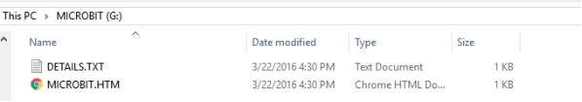

Tips: In micro:bit drive there are two files as show in image above. DETAILS.TXT
records the data information of the micro:bit board. MICROBIT.HTM links to micro:bit official web page (computer need to be online when click).

Results
*Please refer to Lesson 4 Visual Line following on how to program Line recognition.
After program is downloaded, connect micro:bit to Expansion board and switch power to ON. WonderCam will automatically start on Visual Line Following function.
Start by Learning Line ID1. When Line ID1 is recognized, an LED Lights on micro:bit display board will light up move accordingly to the direction of line detected.

